### Hands-on project 1-1: Provide a screenshot for Step 7.

### 

### Hands-on project 1-2: Provide a screenshot for Step 8.

### 

### Hands-on project 1-3: Follow the instruction and complete Step 9.

### For details – Check the attached report “Ch1Prj03Report.rtf”

### Screenshot: Found account number “461562”

### Screenshot: Found the text “book”

Hands-on project 1-6: Follow Step 5 and paste the report here or submit the report as standalone file in pdf or doc.

### For details – Check the attached report “Ch1Prj06Report.rtf”

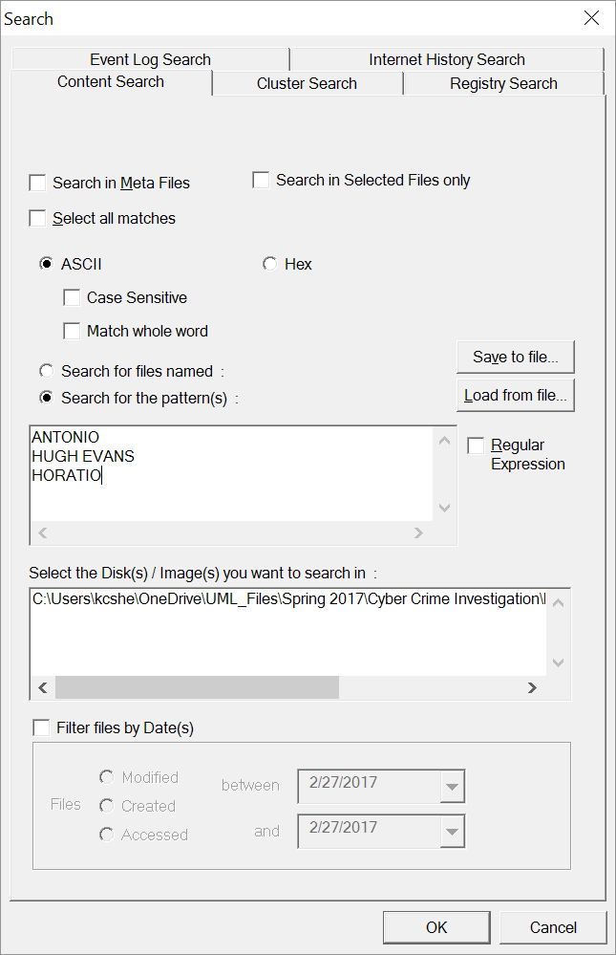  
**Screenshot: Searched for above keywords**

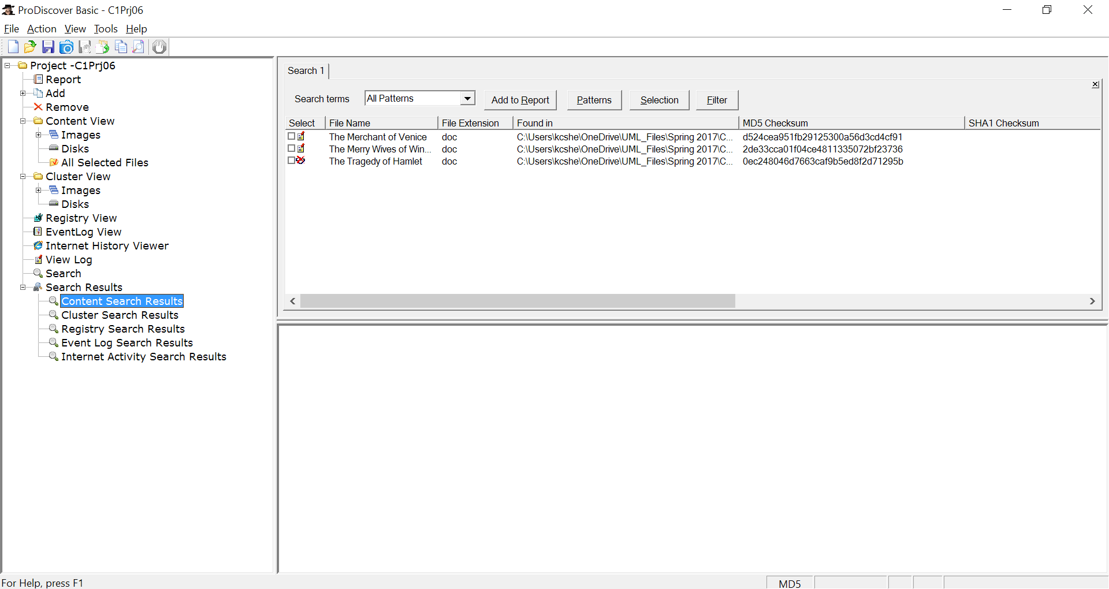  
**Screenshot: Search results – keywords found**